**Transfer Learning-Based Classification Of Poultry Diseases For Enhanced Health Management**

This project aims to develop a Transfer learning-based system for classifying poultry diseases into four categories: Salmonella, New Castle Disease, Coccidiosis, and Healthy. The solution involves creating a robust machine learning model that will be integrated into a mobile application. Farmers will be able to use this application to input data (e.g., symptoms, environmental conditions, and biological samples) and receive an immediate diagnosis along with suggested treatments. The ultimate goal is to provide farmers with a tool that enhances their ability to manage poultry health, thereby reducing disease impact and improving productivity.

**Scenario 1: Outbreak in a Rural Community**

A small rural community relies heavily on poultry farming for its livelihood. Recently, the farmers have noticed an increase in sick birds, exhibiting symptoms such as lethargy, diarrhea, and reduced egg production. Without immediate access to veterinary services, the farmers are struggling to diagnose the problem. Using the new mobile application, they input the observed symptoms and environmental data. The machine learning model quickly classifies the disease as Coccidiosis and provides recommendations for treatment and management. This allows the farmers to take swift action, reducing the spread of the disease and preventing further economic losses.

**Scenario 2: Commercial Poultry Farm Management**

A large commercial poultry farm has implemented the machine learning-based disease classification system to monitor the health of its flocks. Daily health checks are performed, and data is collected via the mobile application. One day, the system identifies symptoms consistent with New Castle Disease in a specific section of the farm. The early detection enables the farm management to quarantine the affected birds and implement control measures promptly, preventing a widespread outbreak and ensuring the overall health of the flock. This proactive approach not only saves costs but also maintains the farm's productivity and reputation.

**Scenario 3: Research and Training for Veterinary Students**

A veterinary school integrates the machine learning-based disease classification application into its curriculum. Students use the app to input data from case studies and real-world scenarios. Through this hands-on training, they learn how to diagnose diseases like Salmonella, New Castle Disease, and Coccidiosis using modern technology. The application also provides detailed information about each disease, treatment options, and management practices. This experience equips future veterinarians with valuable skills in utilizing advanced diagnostic tools, preparing them to better serve the poultry industry.

### download.jpg Prerequisites

* To complete this project, you must require the following software, concepts, and packages
  + Anaconda Navigator:
    - Refer to the link below to download Anaconda Navigator
  + Python packages:
  + Open anaconda prompt as administrator
  + Type “pip install numpy” and click enter.
  + Type “pip install pandas” and click enter.
  + Type “pip install scikit-learn” and click enter.
  + Type ”pip install matplotlib” and click enter.
  + Type ”pip install scipy” and click enter.
  + Type ”pip install seaborn” and click enter.
  + Type ”pip install tenserflow” and click enter.
  + Type “pip install Flask” and click enter.

### Project Structure

Create the Project folder which contains files as shown below

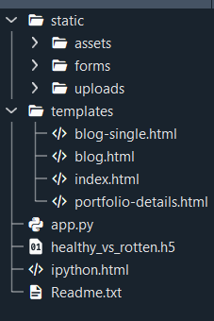

* We are building a Flask application with HTML pages stored in the templates folder and a Python script app.py for scripting.
* Healthy_vs_rotten.h5 is our saved model. Further, we will use this model for flask integration.

### Data Collection And Preparation

ML depends heavily on data. It is the most crucial aspect that makes algorithm training possible. So, this section allows you to download the required dataset.

### Collect The Dataset

Create API Token on Kaggle

* Log in to your Kaggle account.
* Go to your account settings and select "Create New API Token."
* This will download a kaggle.json file containing your API credentials.

Set Up Google Colab Environment

* Open a new notebook in Google Colab.

Upload kaggle.json to Colab

* Upload the kaggle.json file to your Colab notebook. This file contains your Kaggle API credentials.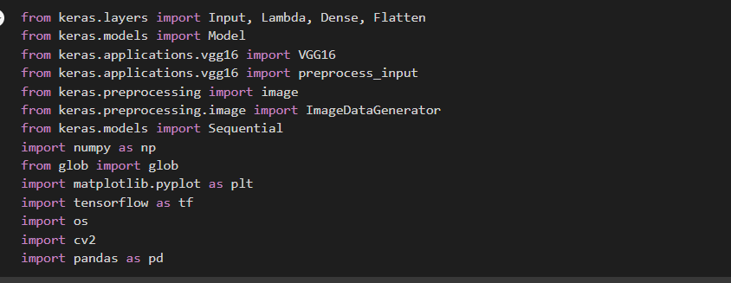

## Dataset: [Link](https://www.kaggle.com/datasets/chandrashekarnatesh/poultry-diseases)

### 1.1Activity:   Import libraries

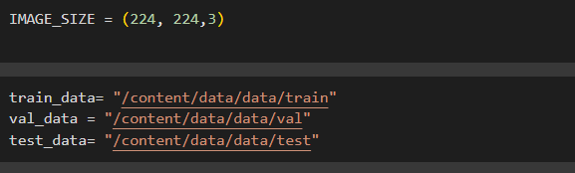

This code uses the VGG16 architecture from Keras for transfer learning to classify images of poultry diseases. It preprocesses the images, creates a model with VGG16 as the base, and adds custom dense and flatten layers for classification. The model is then trained using images loaded from directories with the help of ImageDataGenerator.

### 1.2 Activity: Define the paths for train , test and validation data

Describing the Image size, and assign the paths .

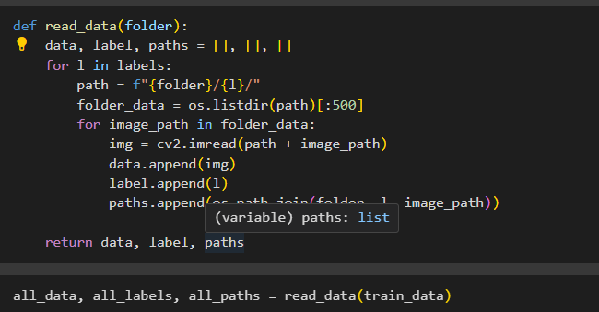

### 1.3 Activity:

The read_data function reads a subset of images from a specified folder, taking 500 images per label category. It iterates through each label, loads the images using OpenCV, and collects the image data, labels, and file paths into separate lists. This function is designed to manage large datasets by processing a smaller, manageable subset of images for training, validation, or testing.

We have taking 500 images from all 4 categories for training, testing and val because  in each dataset from training , testing and validation there 4 lakhs , 70k  and 40k. Those are very huge data to train we don’t have that much ram in so collect 500 from each of the folder.

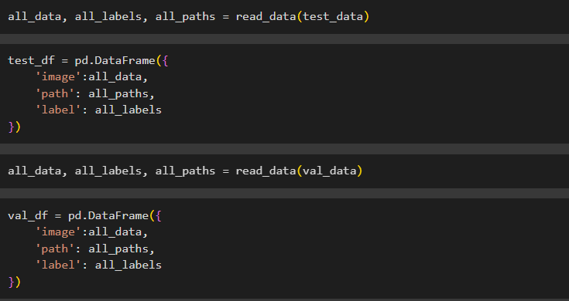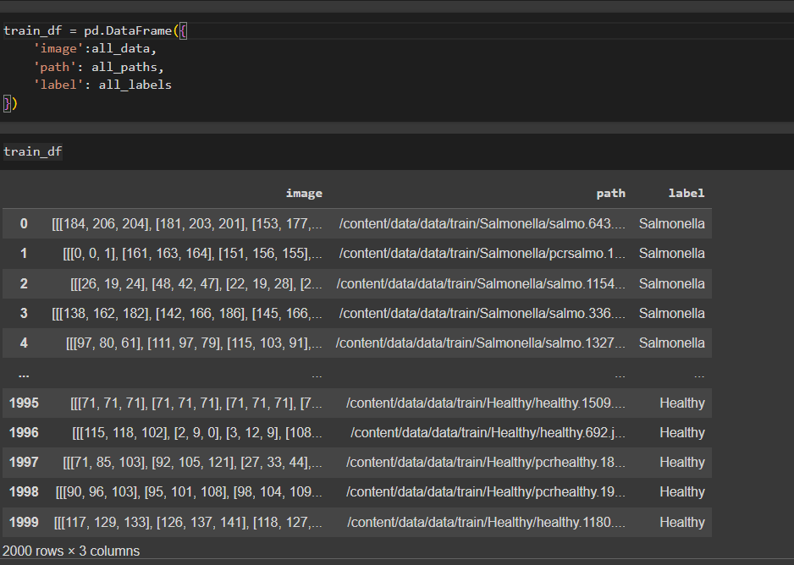

Perform above operations for test and validation data also



### Using ImageDataGenerator

## unnamed (7).png

**This Python code utilizes Keras, a deep learning library, to preprocess image data for a machine learning model. The code imports libraries and creates three data generators: one for training ('train_gen'), one for testing ('test_gen'), and likely one for validation ('val_gen'). These generators are configured to access data from a DataFrame, which provides the location of images, labels, and other relevant information. In essence, this code snippet prepares the image data for the training process of a machine learning model.**

### Model Building:

* Training the model in multiple algorithms  :

 Activity 2.1:VGG16

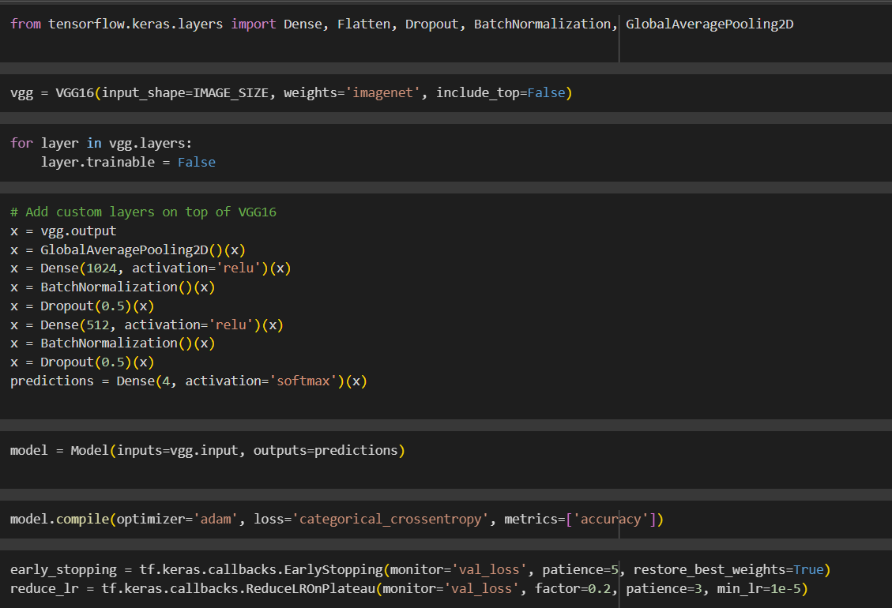

This short Python code snippet builds an image classifier with Keras. It cleverly reuses a pre-trained VGG16 model for its powerful image recognition abilities. Here's the key idea:

* The code loads the VGG16 model, but skips its final classification layers (keeping its feature extraction power).
* It then freezes the pre-trained part to focus training on new custom layers added on top.
* These custom layers likely handle the specific classification task you have in mind.
* Finally, it compiles the whole model for training, setting up how to improve and assess its performance.

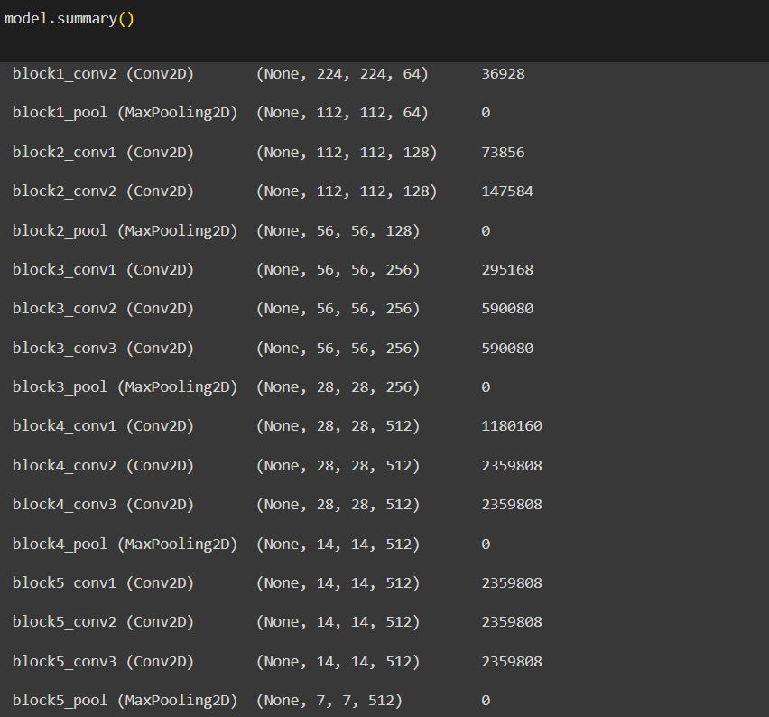

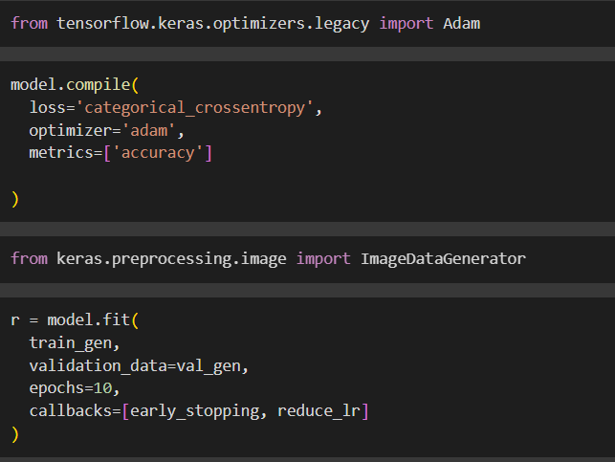

The text shows epochs, which are iterations over the training data. It also shows loss, which is how well the model is performing on the training data, and accuracy, which is how often the model makes correct predictions.

In the output you provided, it appears the model is improving over time as the loss is decreasing and the accuracy is increasing.

Activity 2.2:VGG19

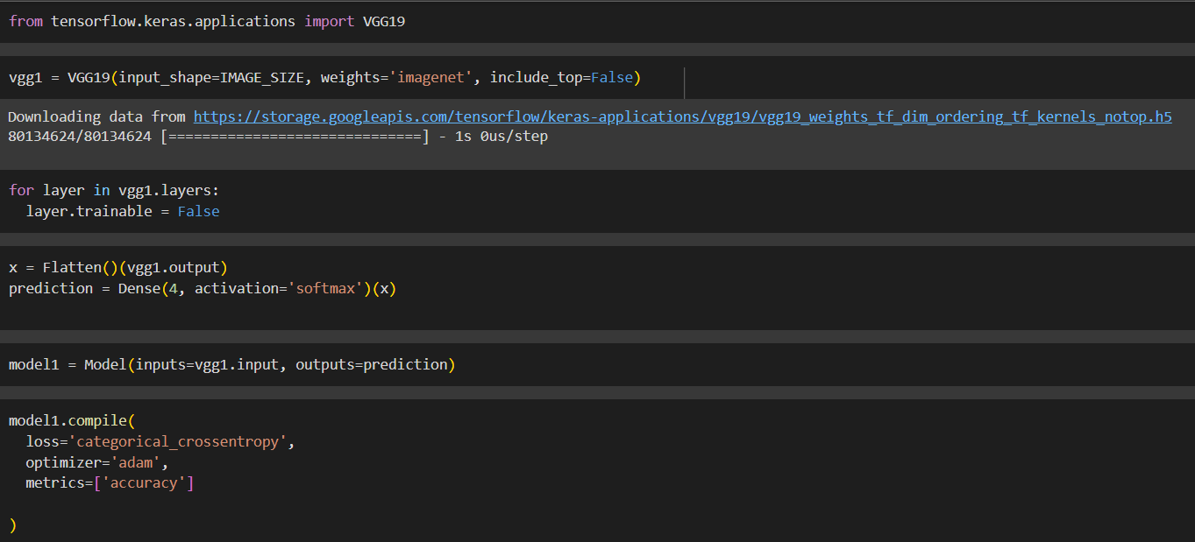

* The first lines import libraries including TensorFlow and Keras.
* It appears to be defining a model with layers including Flatten and Dense which are commonly used in CNN architectures.
* The code then defines a process to compile the model, specifying an optimizer, loss function and metrics.

Overall, the code snippet seems to be training a CNN model on some data. However, without more context it’s difficult to say exactly what the model is being trained for.

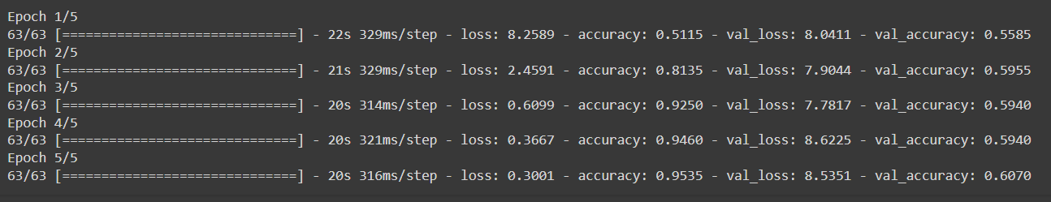

The image you sent shows the results of training a machine learning model over several epochs. Each epoch represents one pass through the training data.

* Loss: The training loss is decreasing over time, which indicates the model is learning to fit the training data better.
* Accuracy: The training accuracy is increasing over time, which indicates the model is making better predictions on the training data.

In machine learning, the goal is to train a model that generalizes well to unseen data. While the model's performance is improving on the training data, it is important to evaluate its performance on a separate validation set to assess itsgeneralizability.

Activity 2.3:ResNet50

: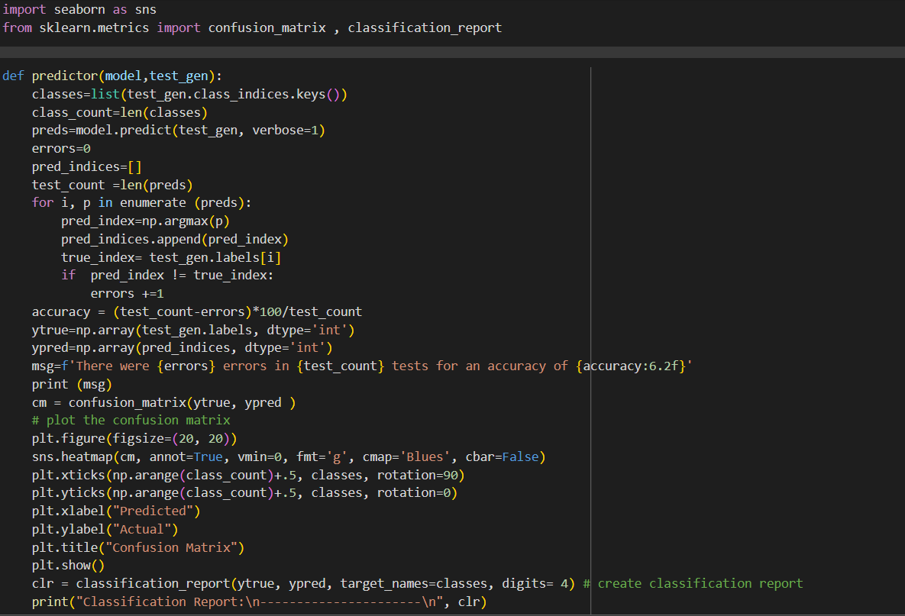

the code appears to be training a convolutional neural network (CNN) model for image classification using Keras. Here's a two-line explanation:

* The model is trained over multiple epochs (iterations) on training data.
* Loss (model's performance) decreases and accuracy (correct predictions) increases over epochs, suggesting the model is learning.

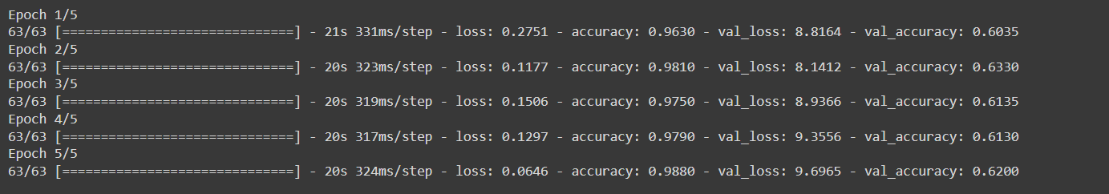

It displays results over five epochs, which are iterations over the training data.

* Loss: The model's training loss is decreasing (0.2751 to 0.0646) signifying the model is improving on the training data.
* Accuracy: Conversely, the training accuracy is increasing (0.9630 to 0.9880) indicating the model is making better predictions on the training data.

It's important to note that while this suggests the model is learning, its generalizability to unseen data needs to be assessed on a separate validation set.

This Python code (Keras library) evaluates a pre-trained image classifier model. It likely:

1. Imports libraries for machine learning and visualization.
2. Loads a pre-trained CNN model (e.g., VGG16) known for image recognition.
3. Prepares new image data for evaluation (resizing, formatting).
4. Feeds the data through the model and generates a confusion matrix.

The confusion matrix shows how well the model classifies the images (ideally high values on the diagonal).

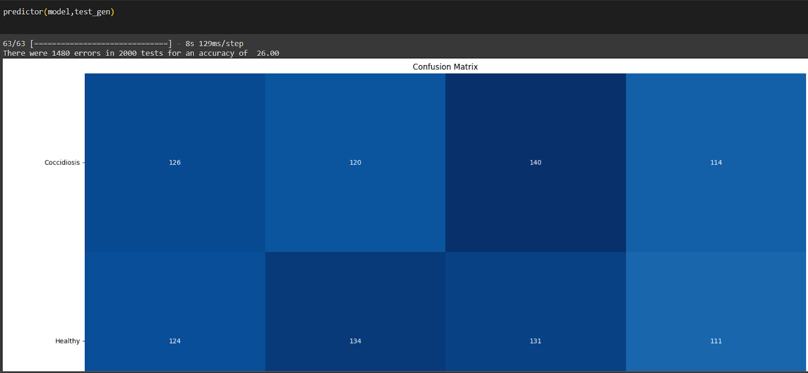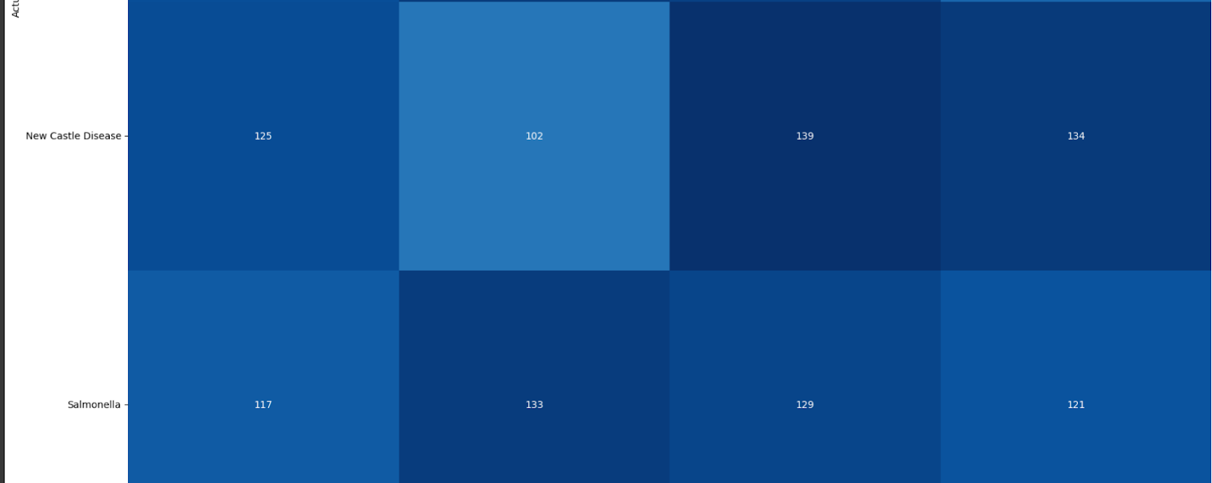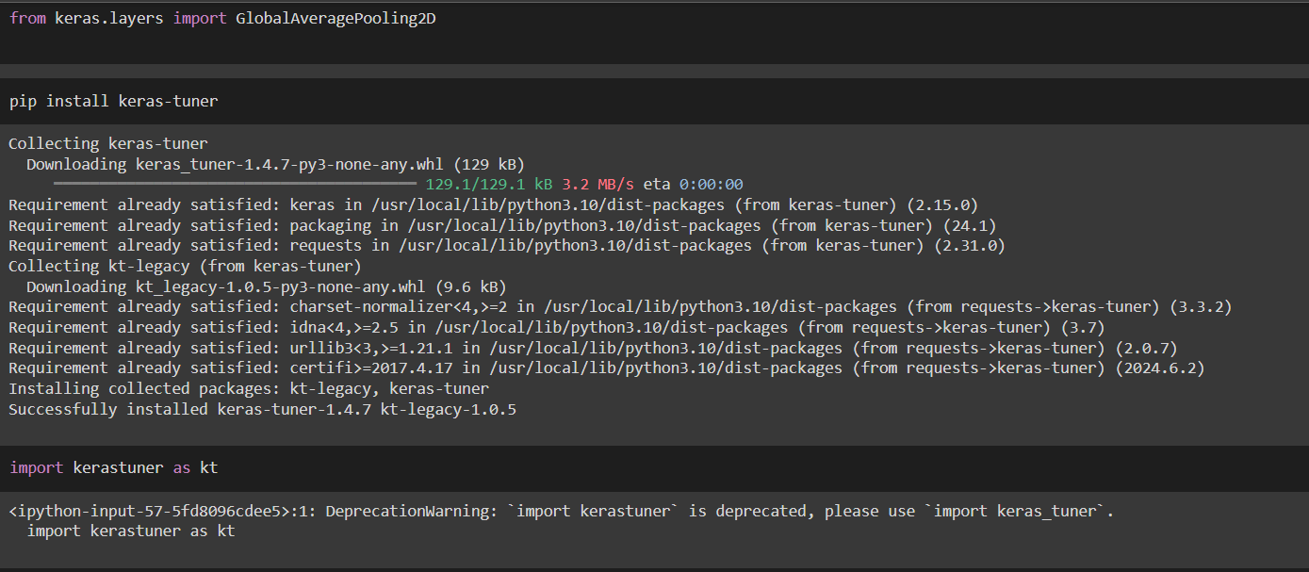

The code snippet appears to be setting up a convolutional neural network (CNN) for image classification using Keras. It likely involves:

1. Data Augmentation: Importing libraries (ImageDataGenerator) to perform transformations like rotation or flipping images. This helps the model learn from variations and generalize better.
2. Data Generators: Creating generators (train_datagen and val_datagen) to load and pre-process training and validation data efficiently during training.

Overall, this code prepares the data for training a CNN model on image classification tasks.

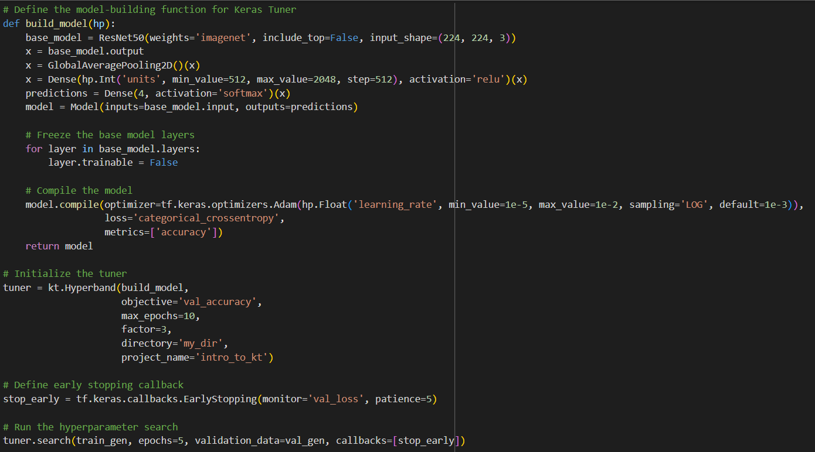

? The code defines a function named build_model that creates a CNN model using Keras.

? It then uses this function along with Hyperband, a hyperparameter tuning technique, to find the optimal configuration (e.g., number of layers, learning rate) for the model that achieves the best validation accuracy.

? It finds the best hyperparameters (like learning rate) from past trials using tuner.get_best_hyperparameters().

? These optimal settings are used to build a new model with tuner.hypermodel.build.

? Finally, the model is trained on training data (train_gen) while monitoring performance on validation data (val_gen).

### Testing Model & Data Prediction

## unnamed (23).png

**The code defines a function named build_model that creates a CNN model using Keras.**

**It then uses this function along with Hyperparameter, a hyperparameter tuning technique, to find the optimal configuration (e.g., number of layers, learning rate) for the model that achieves the best validation accuracy.**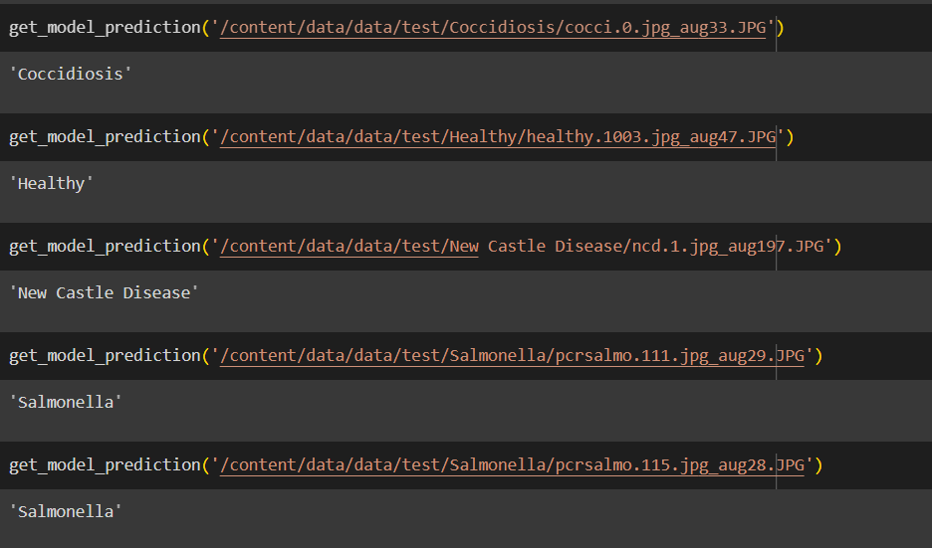

### Application Building

**In this section, we will be building a web application that is integrated into the model we built. A UI is provided for the uses where he has to enter the values for predictions. The enter values are given to the saved model and prediction is showcased on the UI.**

**This section has the following tasks**

* **Building HTML Pages**
* **Building server-side script**

### Building HTML Pages:

Building HTML Pages:

For this project create three HTML files namely

* index.html

And save them in the templates folder.

UI Image preview:

Let’s see what our index.html page looks like:

**Build Python Code:**

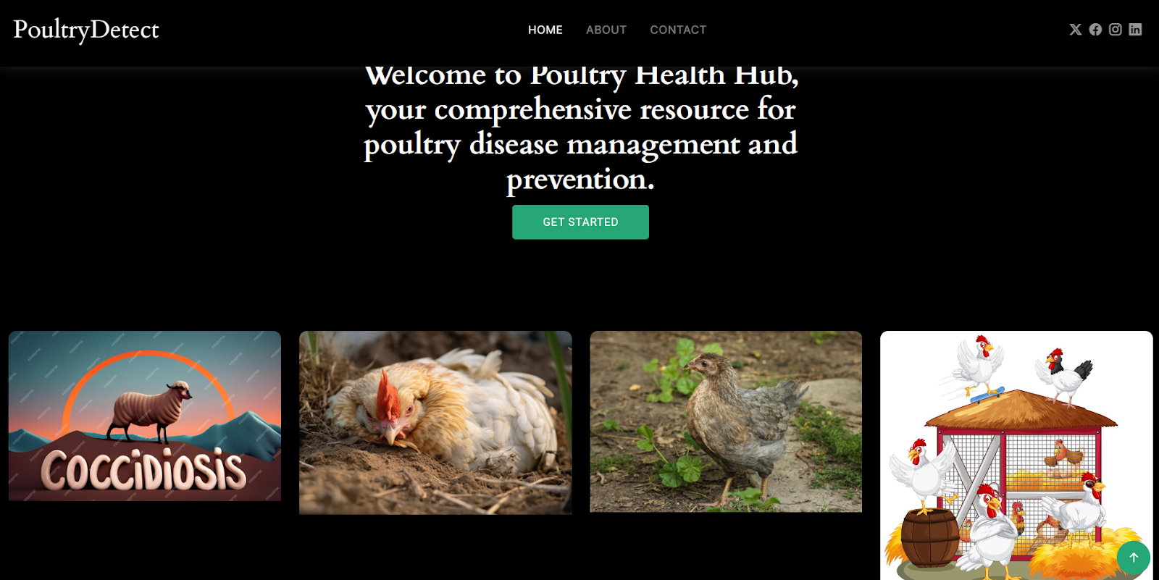

 Import the libraries

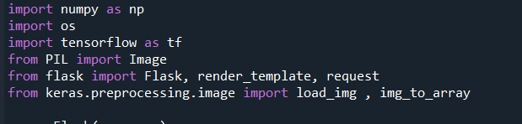

Loading the saved model and initializing the Flask app

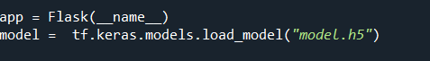

Render HTML pages:

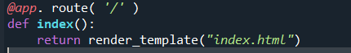

This Flask route /output processes POST requests containing image files. It checks if a file is present and saves it to a designated directory. The uploaded image is then loaded, resized, converted to an array, and preprocessed for model input. Using a pre-trained model, predictions are made on the preprocessed image array. The predicted class is determined based on the highest probability in the prediction array. Finally, the predicted class is passed to an HTML template for rendering, allowing users to see the predicted result. Error handling is implemented to display appropriate messages if no file is included or if the selected file is not an image.

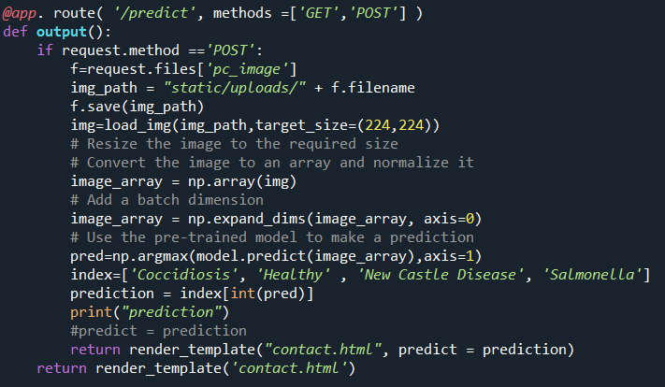

Here we are routing our app to res function. This function retrieves all the values from the HTML page using a Post request. That is stored in an array. This array is passed to the model.predict() function. This function returns the prediction. This prediction value will rendered to the text that we have mentioned in the index.html page earlier.

Main Function:



### Run The Web Application

* **Run the application**
  + Open the Anaconda prompt from the start menu.
  + Navigate to the folder where your Python script is.
  + Now type the “app1.py” command.
  + Navigate to the localhost where you can view your web page.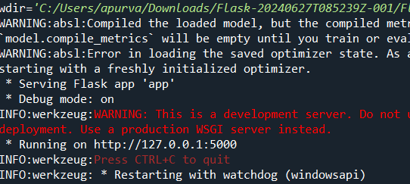
  + Click on the Get Start button, enter the inputs, click on the submit button, and see the result/prediction on the web.
  + The home page looks like this. When you click on the get started “Drop in the image you want to     validate!”, you’ll be redirected to the predict section

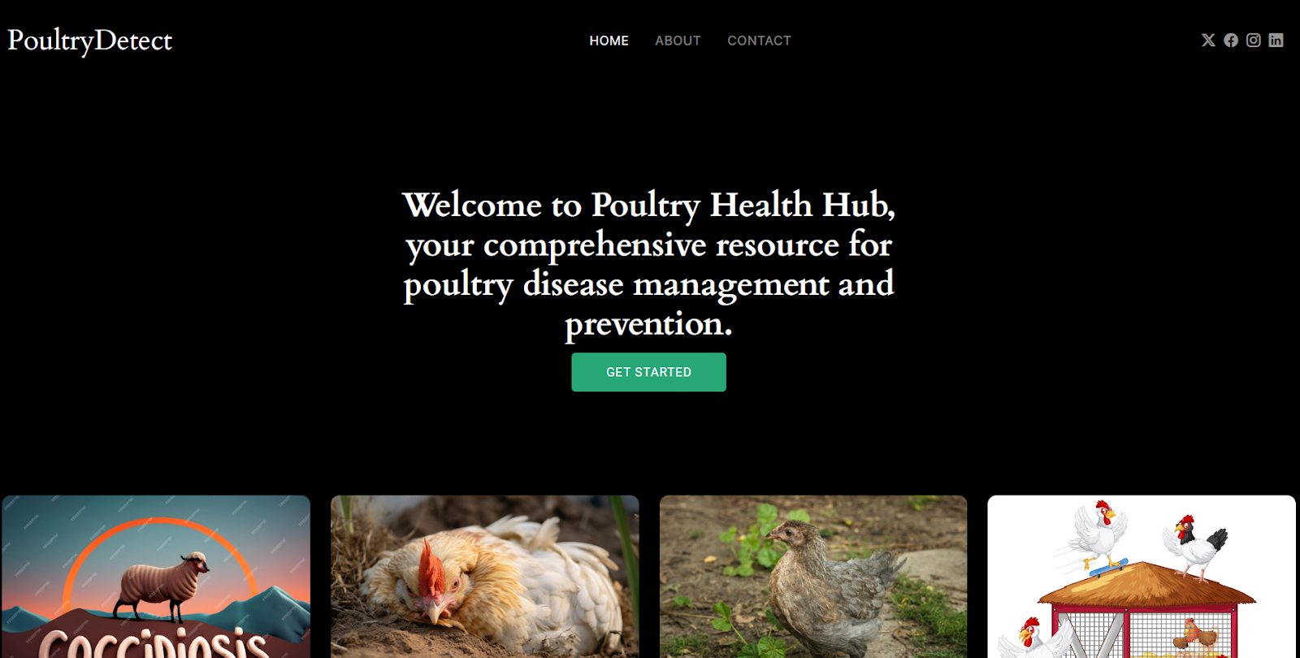

* + click on the Get Started button, Then you’ll be redirected to prediction_page

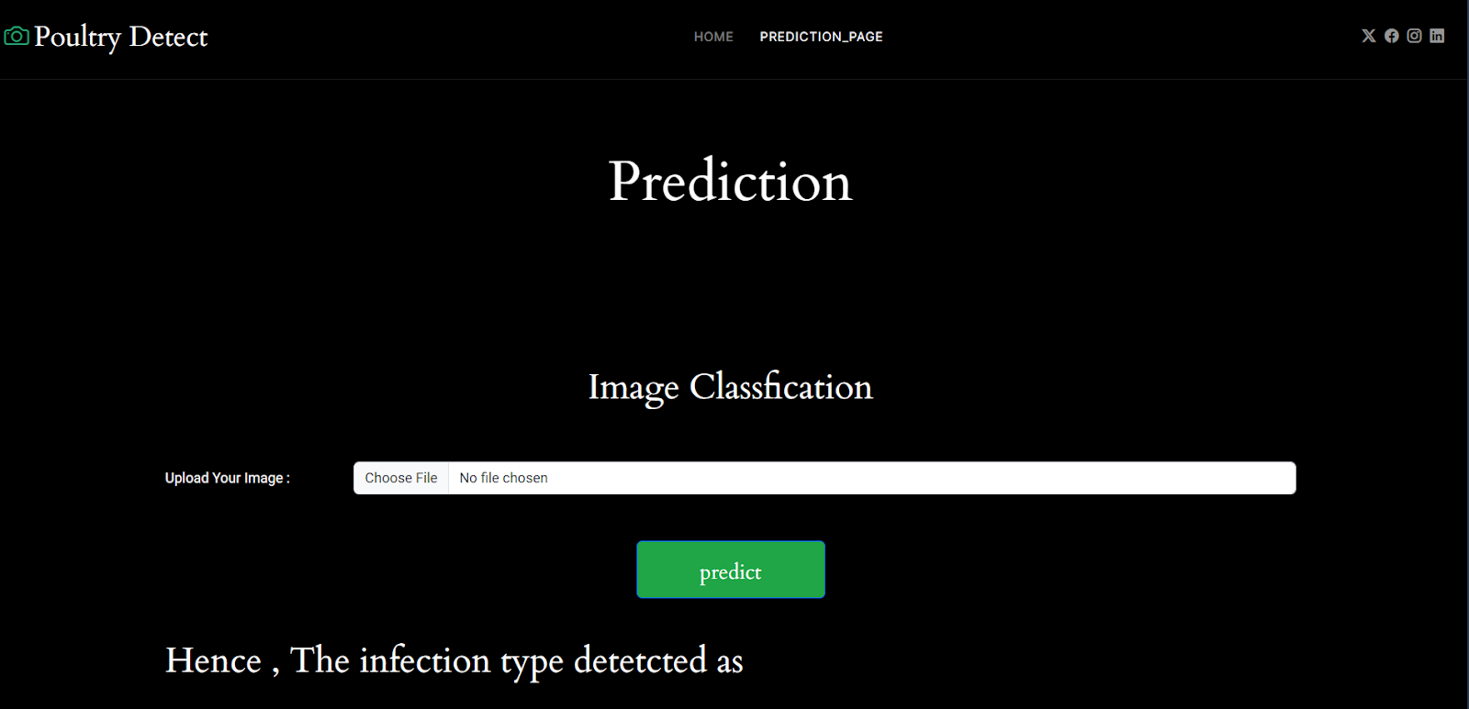

* + Here upload the images from the test data by  selecting the option choose file and the image file should be in JPG , PNG JPEG  format

Here are the images the model predicted